
Jaypee Univeristy of Information Technology, Waknaghat Solan H.P

Tutorial Sheet
Binomial Heap

Q1) What is a binomial tree and binomial heap, state their properties.

Q2) The maximum number of binary trees a binomial heap can have with n nodes is
- Log₂n | - 2^{k}
- Floor (Log₂n) + 1 | - k

Q3) What is order of resultant tree after merging two binomial trees of order k?
- 2*k | - K+1
- k*k | - k+logk

Q4) What does this pseudocode return?
int myfun(heap_arr[])
{
int mini=INF;
for(int i=0;i<tot_node;i++)
mini=min(mini,heap_arr)
return mini;
}
- Last added element to heap | - First element added to heap
- Root of the heap | - Leftmost node of the heap

Q5) Suppose that x is a node in a binomial tree within a binomial heap, and assume that sibling[x] != NIL. If x is not a root, how does degree[sibling[x]] compare to degree[x]? How about if x is a root?
- If not root, deg [sibling[ x]] < deg[x] else deg[ sibling[ x]] > deg[x]
- If not root, deg [sibling[ x]] > deg[x] else deg[ sibling[ x]] < deg[x]
- If not root, deg [sibling[ x]] <= deg[x] else deg[ sibling[ x]] >= deg[x]
- If not root, deg [sibling[ x]] >= deg[x] else deg[ sibling[ x]] <= deg[x]

Q6) A binomial heap contains 13 nodes. Determine the binomial trees present in the heap.[Hint: Use binary representation].
- The heap contains B₀, B₂, B₃ | - The heap contains B₀, B₂, B₄
- The heap contains B₁, B₂, B₃ | - The heap contains B₀, B₂

Q7) Construct a min binomial heap from following values 25, 12, 18, 16, 26, 23, 42, 6, 8, 14, 29, 11, 7, 38, 27.

Q8) A binomial heap contains 15 nodes. Determine the degrees, in decreasing order, of the binomial trees present in the heap.

Q9) Merge the given binomial heaps.

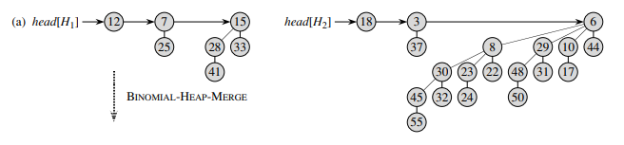

Q10) Extract (delete) minimum element from the binomial heap.
